DSWD-SB-GF-050 | REV 00 | 04 MAR 2022 | 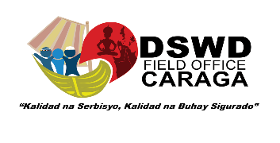
Annex 5. Brochure

GUIDE IN THE PREPARATION OF BROCHURE

Introduction/Rationale
- This shall include the brief background of the establishment and operation of the SWDA

Vision, Mission and Goals/Objectives of the SWDA
- Explicitly state the Vision and Missions of the SWDA
- Vision - refers to the statement that outline where the SWDA want to be in the future
- Mission – refers to the statement that outline how the SWDA will get to where they want to be. Its concern is the present leading to its future.
- State the goal/s of the SWDA
- Goal/s is/are broad statements of intent and desired long-term outcomes of programs in order to achieve the mission
- State the objectives of the SWDA
- The objective should be specific, measurable, attainable, result oriented and time bounded
- Objectives are desired short-term outcomes. These may express the immediate means towards which efforts are directed in order to attain the goal

Beneficiaries
This refers to disadvantaged, marginalized or vulnerable individuals, families, groups, and communities availing services provided by SWDAs. They include but not limited to, the following:

- Abandoned, neglected, orphaned, voluntarily committed, abused and exploited children, and other children in need of special protection;
- Out-of-school youth and other youth with special needs;
- Women;
- Families, such as dysfunctional families;
- Persons with disabilities (PWDs);
- Senior citizens;

- Internally Displaced Individuals and communities such as victim survivors of natural or human-induced calamities or disasters; and
- Indigenous peoples; and

Individuals or groups in crisis situation/s beneficiary that intends to serve considering the SWDA’s Vision, Mission and Goals (VMG) and resources.

Geographical Coverage of Operation

V. Summary of Programs and Services VI. Address and Contact Information of the SWDA
• Incase operating in more than one (1) region, include the list and contact information of the branch and/or satellite

